BATCH – A

NAME: | Manav Dhola
ID NO: | 25AIML007

Practical-1
PR 01: | - Vending machine (VendingMachine.java, main in this file)  - Define an enum Coin with constants ONE, TWO, FIVE, TEN.  - In main, set a snack price of 15 and a running total of 0; create a Scanner.  - Loop: read a coin name, use a switch expression to convert the Coin to its value  (ONE→1, TWO→2, FIVE→5, TEN→10), add it to the total, and print the total so  far.  - Stop the loop once the total reaches 15 or more.  - Print the change to return (total − 15).  Expected output: TEN then FIVE prints “Paid. Change: 0”; TEN then TEN prints  “Paid. Change: 5”.
CODE : | import java.util.Scanner;  enum Coin {  ONE, TWO, FIVE, TEN  }  public class VendingMachine {  public static void main(String[] args) {  Scanner sc = new Scanner(System.in); int price = 15;  int total = 0;  while (total < price) {  System.out.print("Enter coin (ONE/TWO/FIVE/TEN):  ");  String coin = sc.next().toUpperCase();  int value = switch (coin) { case "ONE" -> 1;

case "TWO" -> 2; case "FIVE" -> 5; case "TEN" -> 10;
default -> 0;
};
total = total + value; System.out.println("Total so far: " + total);
}
System.out.println("Paid. Change: " + (total - price)); sc.close();
}
}
OUTPU T: | 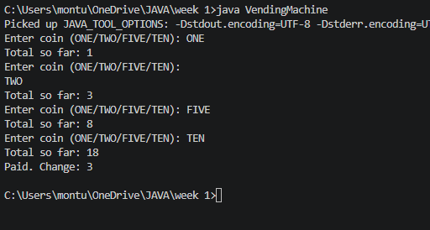
PR 02: | - Vending machine (VendingMachine.java, main in this file)  - Define an enum Coin with constants ONE, TWO, FIVE, TEN.  - In main, set a snack price of 15 and a running total of 0; create a Scanner.  - Loop: read a coin name, use a switch expression to convert the Coin to its value  (ONE→1, TWO→2, FIVE→5, TEN→10), add it to the total, and print the total so  far.  - Stop the loop once the total reaches 15 or more.  - Print the change to return (total − 15).  Expected output: TEN then FIVE prints “Paid. Change: 0”; TEN then TEN prints  “Paid. Change: 5”.
CODE : | import java.util.Scanner;

record Vehicle(String number, String type) {
}
public class TollBooth {

public static void main(String[] args) { Scanner sc = new Scanner(System.in); int totalToll = 0;
int bikeCount = 0; int carCount = 0; int truckCount = 0;
while (true) {
System.out.print("Enter vehicle number (or done): "); String number = sc.next();
if (number.equalsIgnoreCase("done")) { break;
}
System.out.print("Enter vehicle type (bike/car/truck):
");

String type = sc.next().toLowerCase(); Vehicle vehicle = new Vehicle(number, type);
int toll = switch (vehicle.type()) { case "bike" -> 20;
case "car" -> 50; case "truck" -> 150; default -> 0;
};
totalToll = totalToll + toll; switch (vehicle.type()) {

case "bike":
bikeCount++;
break;
case "car":
carCount++;
break;
case "truck":
truckCount++;
break;
}
}
String mostFrequent;
if (bikeCount >= carCount && bikeCount >= truckCount)
{
mostFrequent = "bike";
} else if (carCount >= truckCount) {
mostFrequent = "car";
} else {
mostFrequent = "truck";
}
System.out.println("Total toll: " + totalToll);
System.out.println("Most frequent: " + mostFrequent);
sc.close();
}
}

OUTPU T : | 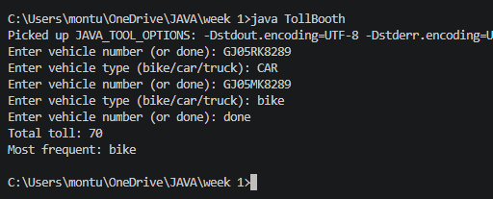

Practical-2
PR 01: | - Smart thermostat (Thermostat.java, main in this file)  - Create class Thermostat with private String location, private int temperature, private  static final int MIN=16 and MAX=30, and private static int activeCount=0.  - Constructor(location, startTemp): store location; set temperature to startTemp if it is  within MIN..MAX else 22; increment activeCount.  - Constructor(location): chain with this(location, 22).  - raise(): if temperature < MAX add 1, else print “Already at maximum (30)”.  - lower(): if temperature > MIN subtract 1, else print “Already at minimum (16)”.  - Add getTemperature() (no setter) and static getActiveCount().  - In main: create two thermostats, call raise() 10 times then lower() 20 times in loops  (printing the temperature each time), then print getActiveCount().  Expected output: temperature rises to 30 then “Already at maximum”, falls to 16  then “Already at minimum”, count 2.
CODE : | public class CinemaShow { private String title;  private int seatsAvailable; private final int capacity;  private static int totalBooked = 0;  public CinemaShow(String title, int capacity) { this.title = title;  this.capacity = capacity; seatsAvailable = capacity;  }  public CinemaShow(String title) { this(title, 100);  }

public boolean book(int n) { if (n <= seatsAvailable) {
seatsAvailable -= n; totalBooked += n; return true;
}
return false;
}
public void cancel(int n) { seatsAvailable += n;
if (seatsAvailable > capacity) seatsAvailable = capacity;
}
public int getSeatsAvailable() { return seatsAvailable;
}

public static int getTotalBooked() { return totalBooked;
}
public static void main(String[] args) {
CinemaShow show = new CinemaShow("Avengers",
50);
System.out.println(show.book(20)); System.out.println(show.getSeatsAvailable());

System.out.println(show.book(15)); System.out.println(show.getSeatsAvailable());

System.out.println(show.book(20)); System.out.println(show.getSeatsAvailable());

show.cancel(10); System.out.println(show.getSeatsAvailable());
System.out.println(show.book(15)); System.out.println(show.getSeatsAvailable());
System.out.println(CinemaShow.getTotalBooked());

}
}
OUTPU T: | 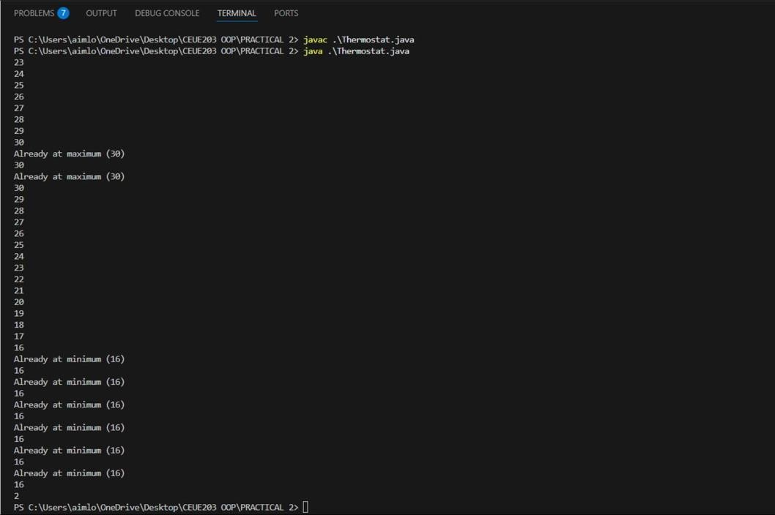
PR 02: | - Cinema show (CinemaShow.java, main in this file)  - Create class CinemaShow with private String title, private int seatsAvailable, private  final int capacity, and private static int totalBooked=0.  - Constructor(title, capacity): set both and seatsAvailable = capacity. Constructor(title): chain with this(title, 100).  - book(int n): if n ≤ seatsAvailable, reduce seatsAvailable by n, add n to totalBooked,  return true; else return false unchanged.  - cancel(int n): increase seatsAvailable by n but never above capacity.  - Add getSeatsAvailable() and static getTotalBooked().  - In main: run a sequence of book and cancel calls, printing the result and seats after  each, then print getTotalBooked().  Expected output: booking more than available prints false and leaves seats unchanged; totalBooked equals the successful bookings.
CODE : | public class CinemaShow { private String title;  private int seatsAvailable; private final int capacity;  private static int totalBooked = 0;  public CinemaShow(String title, int capacity) { this.title = title;  this.capacity = capacity; seatsAvailable = capacity;  }

public CinemaShow(String title) { this(title, 100);
}
public boolean book(int n) { if (n <= seatsAvailable) {
seatsAvailable -= n; totalBooked += n; return true;
}
return false;
}
public void cancel(int n) { seatsAvailable += n;
if (seatsAvailable > capacity) seatsAvailable = capacity;
}

public int getSeatsAvailable() { return seatsAvailable;
}
public static int getTotalBooked() { return totalBooked;
}
public static void main(String[] args) {
CinemaShow show = new CinemaShow("Avengers",
50);

System.out.println(show.book(20)); System.out.println(show.getSeatsAvailable());
System.out.println(show.book(15)); System.out.println(show.getSeatsAvailable());
System.out.println(show.book(20)); System.out.println(show.getSeatsAvailable());
show.cancel(10); System.out.println(show.getSeatsAvailable());

System.out.println(show.book(15)); System.out.println(show.getSeatsAvailable());
System.out.println(CinemaShow.getTotalBooked());
}
}
OUTPU T : | 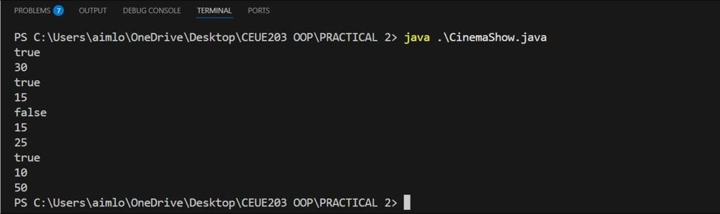

Practical-3
PR 01: | - Distinct points (Point.java + Driver.java with main)  - Create class Point with private int x, y and a constructor.  - Override toString() to return “(x, y)”.  - Override equals(Object) to be true when both x and y match, and hashCode() to agree  (e.g. Objects.hash(x, y)).  - In Driver.main: build a Point[] with some repeated coordinates.  - Count distinct points: for each point, use equals() to check whether it already  appeared earlier; count those that did not.  - Print “Distinct: N”.  Expected output: 5 points with 2 repeats → “Distinct: 3”.
CODE : | import java.util.Objects; public class Point {  private int x; private int y;  Point(int x, int y) { this.x = x; this.y = y;  }  public String toString(int x, int y) { return "(" + x + ", " + y + ")";  }

public boolean equals(Object obj) { if(this == obj) {
return true;
}

if(!(obj instanceof Point)) { return false;
}
Point p1 = (Point) obj;
return this.x == p1.x && this.y == p1.y;
}
public int hashCode() { return Objects.hash(x, y);
}
}
public class Driver {
public static void main(String[] args) { Point[] points = {
new Point(1, 2),
new Point(3, 4),
new Point(1, 2),
new Point(5, 6),
new Point(3, 4),}; int distinct = 0;
for (int i = 0; i < points.length; i++) {

boolean seen = false; for (int j = 0; j < i; j++) {
if (points[i].equals(points[j])) { seen = true;
break;
}
}
}
boolean seen = false;

if (!seen) { distinct++;
}
System.out.println("Number of distinct points: " + distinct);
}
}
OUTPU T: | 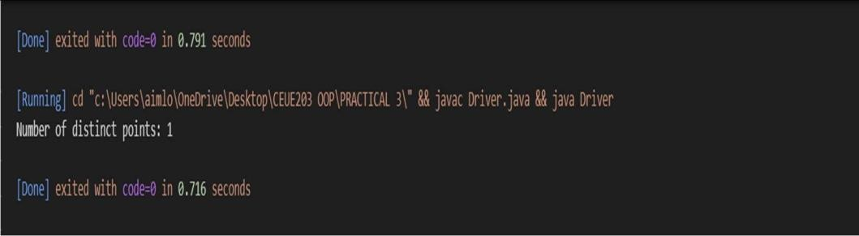
PR 02: | - Duplicate card check (Card.java + Driver.java)  - Create class Card with private String rank, suit and a constructor.  - Override toString() to return rank + “ of ” + suit (e.g. “Queen of Hearts”).  - Override equals()/hashCode() by rank + suit.  - In Driver.main: add cards to a Card[] one at a time; before adding each, use equals()  to check it against the earlier cards.  - Print “Duplicate found: <card>” the first time a repeat appears. Expected output: a second “Ace of Spades” → “Duplicate found: Ace of Spades”.
CODE : | public class Card { private String rank, suit;  public Card(String rank, String suit) { this.rank = rank;  this.suit = suit;  }  public void print() { System.out.print(rank + " of " + suit);  }  public boolean isSame(Card other) {  return this.rank.equals(other.rank) CC this.suit.equals(other.suit);  }  }  public class CardTest { public static void

main(String[] args) { Card[] cards = new Card[5];
int size = 0;
OUTPU T : | 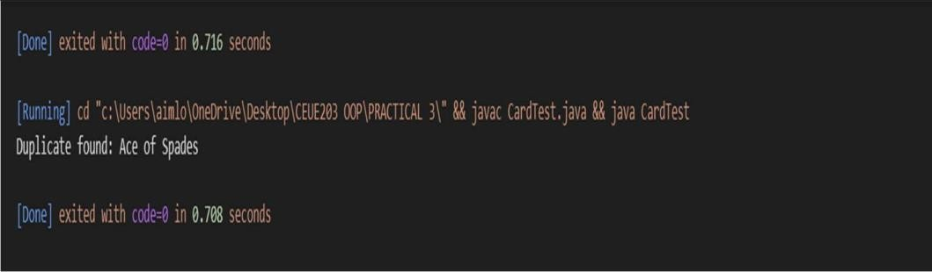

Practical-4
PR 01: | - Password strength (PasswordChecker.java + Driver.java)  - In PasswordChecker, check four rules — length ≥ 8, contains an uppercase letter,  contains a digit, contains a special character — using regex (e.g. “.*[A-Z].*”) or  String methods.  - Write strength(String pw) that counts how many rules pass and returns “Weak” (0–  - , “Medium” (2–3) or “Strong” (4).  (c) In Driver.main: test several passwords; for each, print which rules passed and the  final label.  Expected output: “abc” → Weak; “Abcd1234!” → Strong.
CODE : | public class PasswordChecker {  public static boolean hasLength(String pw) { return pw.length() >= 8;  }  public static boolean hasUppercase(String pw) { return pw.matches(".*[A-Z].*");  }  public static boolean hasDigit(String pw) { return pw.matches(".*[0-9].*");  }  public static boolean hasSpecial(String pw) { return pw.matches(".*[^a-zA-Z0-9].*");  }

public static String strength(String pw) { int count = 0;
if (hasLength(pw)) count++;
if (hasUppercase(pw)) count++;
if (hasDigit(pw)) count++;

if (hasSpecial(pw)) count++;
if (count <= 1) return "Weak";
else if (count <= 3) return "Medium";
else
return "Strong";
}
}
public class Driver {
public static void main(String[] args) { String[] passwords = {
"abc",
"Password", "Pass1234", "Abcd1234!",
"hello@12", "WELCOME1"
};
for (String pw : passwords) { System.out.println("Password: " + pw);

System.out.println("Length >= 8 : " + PasswordChecker.hasLength(pw));
System.out.println("Uppercase : " + PasswordChecker.hasUppercase(pw));
System.out.println("Digit : " + PasswordChecker.hasDigit(pw));
System.out.println("Special Char: " + PasswordChecker.hasSpecial(pw));
System.out.println("Strength : " + PasswordChecker.strength(pw));
System.out.println(" ");
}
}
}
OUTPU T: | 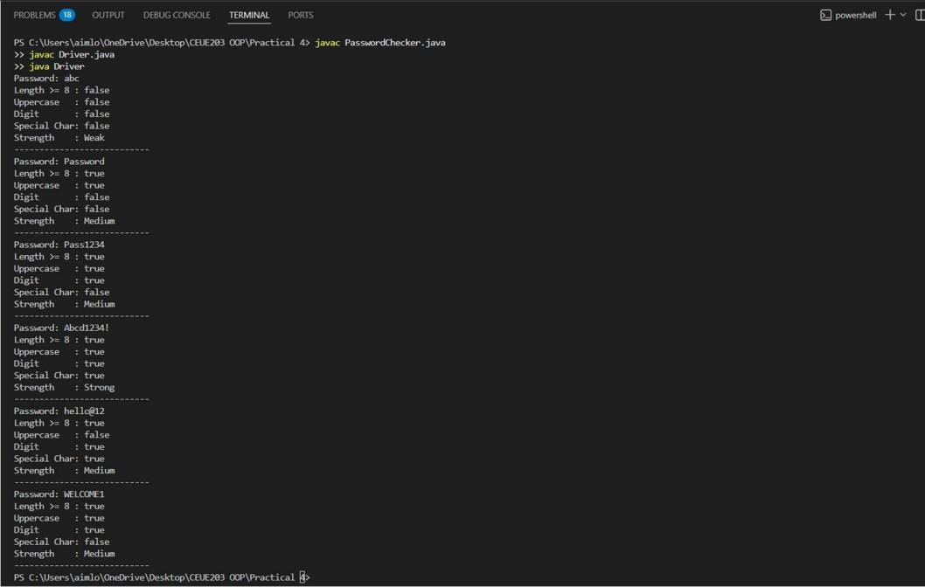
PR 02: | - Chat-log filter (ChatFilter.java + Driver.java)  - In Driver.main, define a String[] of log lines like “10:05 alice Hello there” (include  one malformed line with fewer than 3 parts).  - Read a keyword from the user.  - For each line, split into time/user/message with split(“ ”, 3); skip lines that do not  have 3 parts.  - If the message contains the keyword (case-insensitive), increment a counter and  append “time user: message” to a StringBuilder.  - Print “Matches: N” and the built report.  Expected output: keyword “hello” over 3 lines (1 malformed) → “Matches: 1” and  the matching line.

CODE : | public class ChatFilter {  public static String filterChats(String[] logs, String keyword) {  StringBuilder result = new StringBuilder(); int count = 0;  for (String line : logs) {  String[] parts = line.split(" ", 3); if (parts.length < 3) {  continue;  }  String time = parts[0]; String user = parts[1]; String message = parts[2];  if (message.toLowerCase().contains(keyword.toLowerCase()))  {  count++; result.append(time)  .append(" ")  .append(user)  .append(": ")  .append(message)  .append("\n");  }  }  return "Matches: " + count + "\n" + result.toString();  }  }  import java.util.Scanner; public class Driver1 {  public static void main(String[] args) {  String[] logs = {

"10:05 om Hello there", "10:10 bhavy How are you?", "10:15",
"10:20 manthan Good morning"
};

Scanner sc = new Scanner(System.in);
System.out.print("Enter keyword: "); String keyword = sc.nextLine();
String output = ChatFilter.filterChats(logs, keyword); System.out.println(output);
sc.close();
}
}
OUTPU T : | 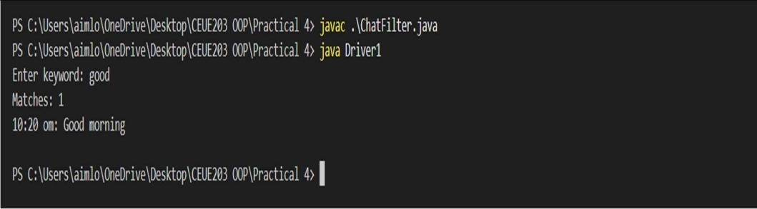

Practical-5
PR 01: | 1. Shape areas: an abstract Shape with abstract area(); subclasses Circle, Rectangle,  Triangle. Put a mix in a Shape[] and loop once to print each area and the running total,  tracking the largest — one loop handling every shape through polymorphism.
CODE : | abstract class Shape {  public abstract double area();  }  class Circle extends Shape { private double radius;

public Circle(double radius) { this.radius = radius;
}
public double area() {
return Math.PI * radius * radius;
}
}
class Rectangle extends Shape { private double width, height;
public Rectangle(double width, double height) { this.width = width;
this.height = height;
}

public double area() { return width * height;
}
}
class Triangle extends Shape { private double base, height;
public Triangle(double base, double height) { this.base = base;
this.height = height;
}

public double area() {
return 0.5 * base * height;
}
}
public class ShapeTest {
public static void main(String[] args) { Shape[] shapes = {
new Circle(5),
new Rectangle(3, 5),

new Triangle(4, 6),}; double totalArea = 0;
double largestArea = Double.MIN_VALUE; Shape largestShape = null;
for (Shape s : shapes) { double area = s.area();
System.out.println("Area: " + area); totalArea += area;
if (area > largestArea) { largestArea = area; largestShape = s;
}
}
System.out.println("Total area = " + totalArea); System.out.println("Largest area = " + largestArea + "
(from " + largestShape.getClass().getSimpleName() + ")");
}
}
OUTPU T: | 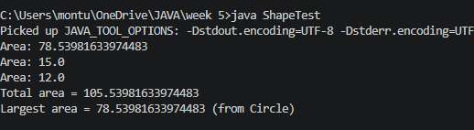
PR 02: | 2. Payroll: an abstract Employee with abstract monthlySalary(); FullTime (fixed), PartTime  (hours × rate) and Intern (stipend), each calling super for the shared name/id.  Loop a  mixed array to print each salary and the total; use instanceof to add a note only for  interns.
CODE : | abstract class Employee {  private String name; private int id;  public Employee(String name, int id) { this.name = name;  this.id = id;  }

public String getName() { return name;
}
public int getId() { return id;
}
public abstract double monthlySalary();
}
class FullTime extends Employee { private double salary;
public FullTime(String name, int id, double salary) { super(name, id);
this.salary = salary;
}
public double monthlySalary() { return salary;
}
}
class PartTime extends Employee { private int hours;
private double rate;
public PartTime(String name, int id, int hours, double rate)
{
super(name, id); this.hours = hours; this.rate = rate;
}
public double monthlySalary() { return hours * rate;
}
}

class Intern extends Employee { private double stipend;
public Intern(String name, int id, double stipend) { super(name, id);
this.stipend = stipend;
}
public double monthlySalary() { return stipend;
}
}
public class PayrollTest {
public static void main(String[] args) { Employee[] employees = {
new FullTime("Manthan", 24, 500000),
new PartTime("Bhavy", 28, 80, 200),
new Intern("Om", 72, 5000),
new FullTime("Aryan", 21, 60000),}; double total = 0;
for (Employee e : employees) { double salary = e.monthlySalary();
System.out.print(e.getName() + " (ID " + e.getId() + ") salary is " + salary);
if (e instanceof Intern) { System.out.print(" [Internship]");
}
System.out.println(); total += salary;
}
System.out.println("Total payroll = " + total);
}
}

OUTPU T : | 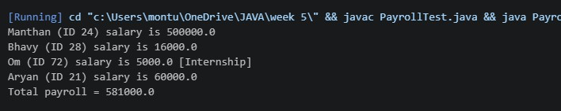

Practical-6
PR 01: | 1. Remote control: an interface Switchable with on()/off() and a default toggle(); Fan and  Light implement it. Loop over a Switchable[] toggling each. Then add a functional  interface that decides, given a device and an hour, whether it may switch on, and supply it  once as an anonymous class and once as a lambda.
CODE : | interface Switchable { void on();  void off();  default void toggle() { on();  off();  }  }  class Fan implements Switchable { public void on() {  System.out.println("Fan is ON");  }  public void off() { System.out.println("Fan is OFF");  }  }  class Light implements Switchable { public void on() {  System.out.println("Light is ON");  }

public void off() { System.out.println("Light is OFF");
}
}

@FunctionalInterface interface Permission {
boolean maySwitchOn(String device, int hour);
}
public class RemoteControl {
public static void main(String[] args) { Fan fan = new Fan();
Light light = new Light(); Switchable[] devices = {fan, light};
System.out.println("Toggling devices:");
for (Switchable device : devices) { device.toggle();
}
Permission p1 = new Permission() {
public boolean maySwitchOn(String device, int hour)
{
return hour >= 6 && hour <= 22;
}
};

System.out.println("Fan at 10: " + p1.maySwitchOn("Fan", 10));
System.out.println("Light at 2: " + p1.maySwitchOn("Light", 2));
Permission p2 = (device, hour) -> hour >= 6 && hour <=
22;
System.out.println("\nUsing lambda:");

System.out.println("Fan at 8: " + p2.maySwitchOn("Fan", 8));
System.out.println("Light at 3: " + p2.maySwitchOn("Light", 3));
}
}
OUTPU T: | 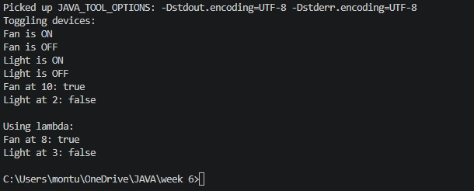
PR 02: | 2. Notification senders: a functional interface Notifier with send(String); make email and  SMS senders as lambdas, hold them in an array, and broadcast one message through all.  Add a marker interface Urgent and send twice for senders marked urgent.
CODE : | @FunctionalInterface interface Notifier {  void send(String message);  }  interface Urgent {  }  class Email implements Urgent { String name;  Email(String name) { this.name = name;  }  }  class SMS { String name;  SMS(String name) { this.name = name;  }

}
public class NotificationSender {

public static void main(String[] args) {

Email email = new Email("Email"); SMS sms = new SMS("SMS");
Notifier email_sender = message -> System.out.println("Email: " + message);
Notifier sms_sender = message -> System.out.println("SMS: " + message);
Notifier[] senders = {email_sender, sms_sender}; String message = "Meeting at 5 PM";
for (Notifier sender : senders) { sender.send(message);
if (sender == email_sender && email instanceof Urgent) {
sender.send(message);
}
}
}
}
OUTPU T : | 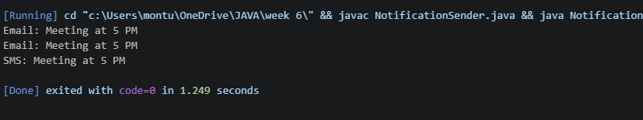

Practical-7
PR 01: | 1. Form validator: define @NotBlank and @MaxLength(int) for fields and annotate a SignupForm. Write a checker that uses reflection to read each  field’s annotations and returns the list of validation errors for a given object.
CODE : | import java.lang.annotation.*; import java.lang.reflect.Field;

import java.util.*;
@Retention(RetentionPolicy.RUNTIME) @Target(ElementType.FIELD) @interface NotBlank {
}

@Retention(RetentionPolicy.RUNTIME) @Target(ElementType.FIELD) @interface MaxLength {
int value();
}
class SignupForm {
@NotBlank @MaxLength(10) String username;

@NotBlank @MaxLength(20) String email;
SignupForm(String username, String email) { this.username = username;
this.email = email;
}
}

public class Main {
public static void main(String[] args) throws Exception { SignupForm form = new SignupForm("",
"abcdefghijklmnop@gmail.com");
List<String> errors = new ArrayList<>();
for (Field field : form.getClass().getDeclaredFields()) { field.setAccessible(true);
String value = (String) field.get(form);

// Check NotBlank
if (field.isAnnotationPresent(NotBlank.class)) { if (value == null || value.trim().isEmpty()) {
errors.add(field.getName() + " cannot be
blank");
}
}
// Check MaxLength
if (field.isAnnotationPresent(MaxLength.class)) {
MaxLength max = field.getAnnotation(MaxLength.class);
if (value != null && value.length() > max.value()) { errors.add(field.getName()
+ " is too long. Maximum "
+ max.value() + " characters allowed");
}
}
}
if (errors.isEmpty()) { System.out.println("Form is valid");
} else {
for (String error : errors) { System.out.println(error);
}
}
}
}
OUTPU T: | 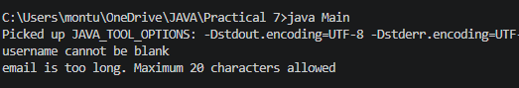
PR 02: | 2. Mini test runner: define a @Run annotation and mark some no-arg methods of a class with it. Use reflection to find and invoke only the @Run methods and report how many ran — the idea behind how JUnit finds @Test  methods.
CODE : | import java.lang.annotation.*; import java.lang.reflect.Method;

@Retention(RetentionPolicy.RUNTIME) @Target(ElementType.METHOD) @interface Run {
}
class MyTests { @Run
public void test1() {
System.out.println("Test 1 executed");
}
@Run
public void test2() { System.out.println("Test 2 executed");
}
public void normalMethod() { System.out.println("Normal method");
}
}
public class Mini {
public static void main(String[] args) throws Exception { MyTests obj = new MyTests();
int count = 0;

Method[] methods = obj.getClass().getDeclaredMethods();

for (Method method : methods) {
if (method.isAnnotationPresent(Run.class) && method.getParameterCount() == 0) {
method.invoke(obj); count++;
}
}

System.out.println("Total methods executed: " + count);
}
}
OUTPU T : | 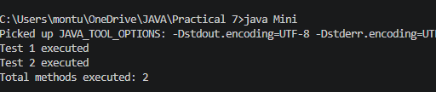

Practical-8
PR 01: | 1. Guarded calculator: read two numbers and an operator; throw a custom DivideByZeroException and catch invalid-number input separately, printing a clear message each time; loop until a valid calculation succeeds and use finally  to log each attempt.
CODE : | import java.util.Scanner; public class Calculator {  public static void main(String[] args) { Scanner sc = new Scanner(System.in);  try {  System.out.print("Enter first number: "); double num1 = sc.nextDouble();  System.out.print("Enter second number: "); double num2 = sc.nextDouble();  if (num1 < 0 || num2 < 0) {  throw new InvalidNumberException("Negative numbers are not allowed!");  }  if(num1==0 || num2==0){  throw new InvalidNumberException("Multiplication By Zero is not allowed!");  }  System.out.print("Enter operator (+, -, *, /): ");

char op = sc.next().charAt(0);
System.out.println("You entered: " + num1 + " " + op
+ " " + num2);
double result = 0; if (op == '+') {
result = num1 + num2;
} else if (op == '-') { result = num1 - num2;
} else if (op == '*') { result = num1 * num2;
} else if (op == '/') { if (num2 == 0) {
throw new DivideByZeroException("Cannot divide by zero!");
}
result = num1 / num2;
} else {
throw new InvalidNumberException("Invalid operator entered!");
}

System.out.println(num1 + " " + op + " " + num2 + " = " + result);
} catch (DivideByZeroException e) { System.out.println("Error: " + e.getMessage());
} catch (InvalidNumberException e) { System.out.println("Error: " + e.getMessage());
} catch (Exception e) { System.out.println("Unexpected error: " +
e.getMessage());
} finally {
System.out.println("Exiting the program."); sc.close();
}
}
}
class DivideByZeroException extends Exception {

public DivideByZeroException(String message) { super(message);
}
}
class InvalidNumberException extends Exception { public InvalidNumberException(String message) {
super(message);
}
}
OUTPU T: | 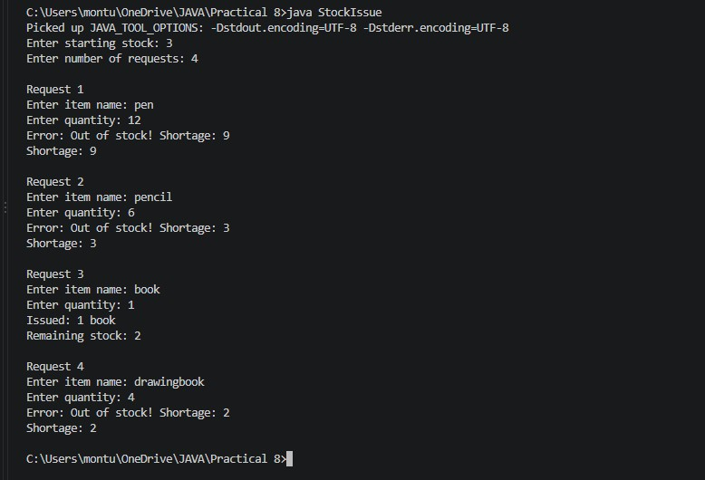
PR 02: | 2. Stock issue: a Warehouse where issue(item, qty) throws a custom checked OutOfStockException carrying the shortfall, and InvalidQuantityException for  qty ≤ 0.Process a list of requests, catching and reporting each failure without stopping the run.
CODE : | import java.util.Scanner;  class OutOfStockException extends Exception { private int shortage;  public OutOfStockException(int shortage) { super("Out of stock! Shortage: " + shortage); this.shortage = shortage;  }  public int getShortage() {

return shortage;
}
}
class InvalidQuantityException extends Exception { public InvalidQuantityException() {
super("Invalid quantity! Must be greater than 0.");
}
}
class Warehouse { private int stock;

public Warehouse(int stock) { this.stock = stock;
}
public void issue(String item, int qty) throws OutOfStockException,
InvalidQuantityException {
if (qty <= 0) {
throw new InvalidQuantityException();
}
if (qty > stock) {
throw new OutOfStockException(qty - stock);
}

stock -= qty;
System.out.println("Issued: " + qty + " " + item); System.out.println("Remaining stock: " + stock);
}
}
public class StockIssue {
public static void main(String[] args) { Scanner sc = new Scanner(System.in);
System.out.print("Enter starting stock: "); int stock = sc.nextInt();
if (stock < 0) {

System.out.println("Stock cannot be negative."); sc.close();
return;
}
Warehouse w = new Warehouse(stock);

System.out.print("Enter number of requests: "); int n = sc.nextInt();
sc.nextLine();
for (int i = 1; i <= n; i++) { System.out.println("\nRequest " + i);
System.out.print("Enter item name: "); String item = sc.nextLine();
System.out.print("Enter quantity: "); int qty = sc.nextInt();
sc.nextLine();
try {
w.issue(item, qty);
} catch (OutOfStockException e) { System.out.println("Error: " + e.getMessage()); System.out.println("Shortage: " + e.getShortage());
} catch (InvalidQuantityException e) { System.out.println("Error: " + e.getMessage());
}
}
sc.close();
}
}

OUTPU T :

Practical-9
PR 01: | 1. Counter race: several threads each increment a shared counter many Ɵmes. Run it without synchronizaƟon to watch the total come out too low, then make the increment synchronized and confirm it is exactly right every  run.
CODE : | class Counter { int count = 0;  void increment() { count++;  }  }  class CounterThread extends Thread { Counter counter;  int times;  CounterThread(Counter counter, int times) { this.counter = counter;  this.times = times;  }  public void run() {  for (int i = 0; i < times; i++) {

counter.increment();
}
}
}
public class CounterRace {
public static void main(String[] args) throws Exception { int threadCount = 10;
int times = 100000;
// Without synchronization Counter counter = new Counter();
Thread[] threads = new Thread[threadCount];
for (int i = 0; i < threadCount; i++) {
threads[i] = new CounterThread(counter, times); threads[i].start();
}
for (Thread thread : threads) { thread.join();
}
System.out.println("Without synchronization: " + counter.count);
System.out.println("Expected: " + (threadCount * times));
// With synchronization
Counter counter2 = new Counter();
Thread[] threads2 = new Thread[threadCount]; for (int i = 0; i < threadCount; i++) {
threads2[i] = new Thread(() -> { for (int j = 0; j < times; j++) {
synchronized (counter2) { counter2.count++;
}

}
});
threads2[i].start();
}

for (Thread thread : threads2) { thread.join();
}
System.out.println("With synchronization: " + counter2.count);
System.out.println("Expected: " + (threadCount * times));
}
}
OUTPU T: | 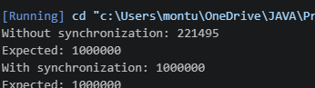
PR 02: | 2. Seat booking race: a shared seatsLeŌ of 5 with about 10 threads each trying to book one seat. Without synchronizaƟon show that more than 5 can  succeed (oversell); with a synchronized book() exactly 5 do.
CODE : | class SeatBooking { int seatsLeft = 5;  void book() {  if (seatsLeft > 0) { try {  Thread.sleep(10);  } catch (InterruptedException e) { e.printStackTrace();  }  seatsLeft--; System.out.println(Thread.currentThread().getName()  + " booked a seat.");  } else {  System.out.println(Thread.currentThread().getName()  + " failed - No seats left.");  }  }

synchronized void bookSynchronized() { if (seatsLeft > 0) {
try {
Thread.sleep(10);
} catch (InterruptedException e) { e.printStackTrace();
}
seatsLeft--; System.out.println(Thread.currentThread().getName()
+ " booked a seat.");
} else {
System.out.println(Thread.currentThread().getName()
+ " failed - No seats left.");
}
}
}

public class SeatBookingRace {
public static void main(String[] args) throws Exception {
// Without synchronization
SeatBooking booking = new SeatBooking(); Thread[] threads = new Thread[10];
System.out.println("WITHOUT SYNCHRONIZATION:");

for (int i = 0; i < 10; i++) { threads[i] = new Thread(
() -> booking.book(),
"Thread-" + (i + 1)
);
threads[i].start();
}
for (Thread thread : threads) { thread.join();
}
System.out.println("Seats left: " + booking.seatsLeft);

// With synchronization
SeatBooking booking2 = new SeatBooking(); Thread[] threads2 = new Thread[10]; System.out.println("\nWITH SYNCHRONIZATION:");
for (int i = 0; i < 10; i++) { threads2[i] = new Thread(
() -> booking2.bookSynchronized(), "Thread-" + (i + 1)
);
threads2[i].start();
}
for (Thread thread : threads2) { thread.join();
}

System.out.println("Seats left: " + booking2.seatsLeft);
}
}
OUTPU T : | 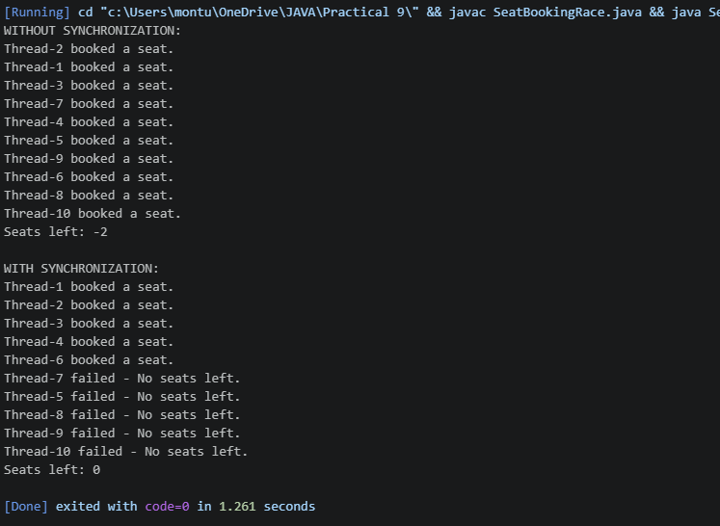

Practical-10
PR 01: | 1. Counter race: several threads each increment a shared counter many Ɵmes. Run it without synchronizaƟon to watch the total come out too low, then make the increment synchronized and confirm it is exactly right every  run.
CODE : | import java.util.concurrent.ExecutorService; import java.util.concurrent.Executors; import java.util.concurrent.TimeUnit;  public class ThreadPoolRunner {  public static void main(String[] args) { ExecutorService executor =  Executors.newFixedThreadPool(3);  for (int i = 1; i <= 10; i++) { int taskId = i;  executor.submit(() -> { try {  System.out.println(  "Task " + taskId + " is running on " + Thread.currentThread().getName());  Thread.sleep(1000); System.out.println(  "Task " + taskId + " completed by " + Thread.currentThread().getName());  } catch (InterruptedException e) { Thread.currentThread().interrupt();  }  });  }  executor.shutdown(); try {  // Wait until all tasks are completed

if (executor.awaitTermination(30, TimeUnit.SECONDS)) {
System.out.println("All tasks completed.");
} else {
System.out.println("Timeout! Some tasks are still running.");
}
} catch (InterruptedException e) { Thread.currentThread().interrupt();
}
}
}
OUTPU T: | 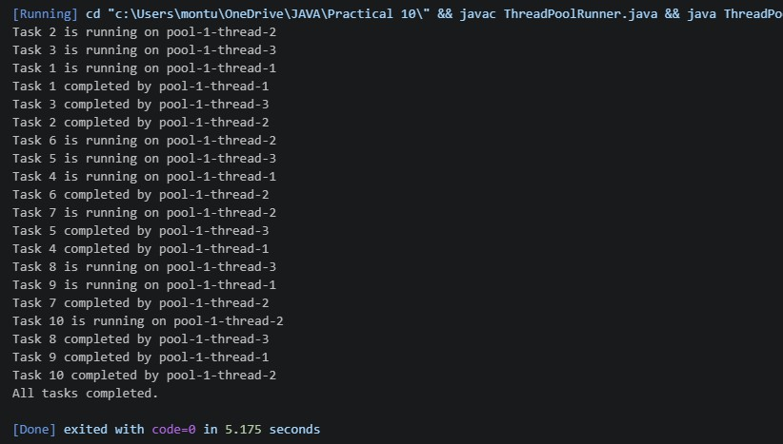
PR 02: | 2. Producer–consumer: one thread adds numbers to a small shared buffer and another removes them, coordinated with wait()/noƟfy(); produce and  consume a fixed number of items in order with none lost.
CODE : | class SharedBuffer {  private int item;  private boolean available = false;  public synchronized void produce(int value) throws InterruptedException {  // Wait if buffer is full while (available) {  wait();  }  item = value;

available = true; System.out.println("Produced: " + value);
// Notify consumer notify();
}
// Consumer removes an item
public synchronized int consume() throws InterruptedException {
// Wait if buffer is empty while (!available) {
wait();
}
int value = item; available = false;

System.out.println("Consumed: " + value);
// Notify producer notify();
return value;
}
}

public class ProducerConsumer { public static void main(String[] args) {
SharedBuffer buffer = new SharedBuffer(); int numberOfItems = 10;
// Producer thread
Thread producer = new Thread(() -> { try {
for (int i = 1; i <= numberOfItems; i++) { buffer.produce(i); Thread.sleep(200);

}
} catch (InterruptedException e) { Thread.currentThread().interrupt();
}
});

// Consumer thread
Thread consumer = new Thread(() -> { try {
for (int i = 1; i <= numberOfItems; i++) { buffer.consume(); Thread.sleep(300);
}
} catch (InterruptedException e) { Thread.currentThread().interrupt();
}
});
producer.start(); consumer.start();
try {
producer.join(); consumer.join();
} catch (InterruptedException e) { Thread.currentThread().interrupt();
}
System.out.println("All items produced and consumed.");
}
}

OUTPU T : | 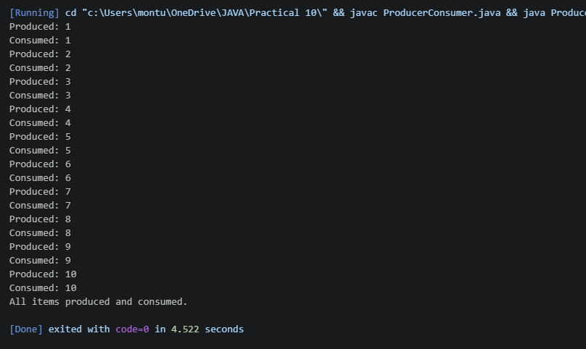

Practical-11
PR 01: | 1. Save/load: make a small class Serializable, save an array of its objects to a file with Object Output Stream, then read it back into fresh objects and  confirm the values survived. Mark one field transient and show it is not saved.
CODE : | import java.io.*;  class Student implements Serializable {  private static final long serialVersionUID = 1L; int rollNo;  String name;  // This field will NOT be saved transient String password;  Student(int rollNo, String name, String password) { this.rollNo = rollNo;  this.name = name; this.password = password;  }  void display() { System.out.println(  "Roll No: " + rollNo +

", Name: " + name +
", Password: " + password
);
}
}

public class SaveLoad {
public static void main(String[] args) { Student[] students = {
new Student(1, "Manthan", "Manthan8289"), new Student(2, "Om", "Om123"),
new Student(3, "Amit", "amit123")
};
// Save objects
try (ObjectOutputStream out = new ObjectOutputStream(
new FileOutputStream("students.dat"))) { out.writeObject(students); System.out.println("Students saved successfully.");
} catch (IOException e) { e.printStackTrace();
}
// Load objects
try (ObjectInputStream in =
new ObjectInputStream(
new FileInputStream("students.dat"))) {
Student[] loadedStudents = (Student[]) in.readObject();
System.out.println("\nStudents loaded from file:"); for (Student s : loadedStudents) {
s.display();
}

} catch (IOException | ClassNotFoundException e) { e.printStackTrace();
}
}
}
OUTPU T: | 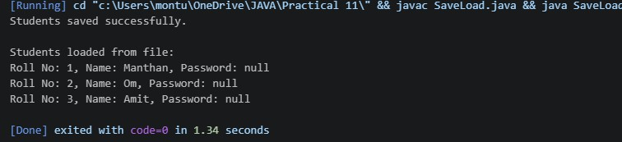
PR 02: | 2. Log analyzer: create a few text files, then use Path/Files to read each line by line and count the total lines and how many contain a keyword across all  files; also print each file’s size from its aƩributes.
CODE : | import java.io.IOException; import java.nio.file.*; import java.util.List;  public class LogAnalyzer {  public static void main(String[] args) { String keyword = "ERROR";  Path[] files = { Paths.get("log1.txt"),  Paths.get("log2.txt"), Paths.get("log3.txt")  };  int totalLines = 0;  int keywordLines = 0;  try {  for (Path file : files) {  // Get file size  long size = Files.size(file);  System.out.println("\nFile: " + file.getFileName()); System.out.println("Size: " + size + " bytes");  // Read file line by line  List<String> lines = Files.readAllLines(file);

 |  |  | for (String line : lines) {
 |  |  | totalLines++;
 |  |  | if (line.contains(keyword)) {
 |  |  | keywordLines++;
 |  |  | }
 |  |  | }
 |  |  | }
 |  |  | System.out.println("\n----- SUMMARY ");
 |  |  | System.out.println("Total lines: " + totalLines);
 |  |  | System.out.println(
 |  |  | "Lines containing '" + keyword + "': "
 |  |  | + keywordLines
 |  |  | );
 |  |  | } catch (IOException e) {
 |  |  | e.printStackTrace();
 |  |  | }
 |  | }
 | }
OUTPU T : | 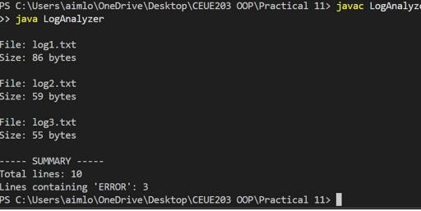

Practical-12
PR 01: | 1. Word frequency: split a paragraph into words, count each in a HashMap,  and print the words sorted by frequency (highest first) using a Comparator.
CODE : | import java.util.*;

public class WordFrequency {
public static void main(String[] args) {
String paragraph = "java is easy and java is powerful and java is popular";

HashMap<String, Integer> map = new HashMap<>(); String[] words = paragraph.toLowerCase().split("\\s+");
// Count frequency
for (String word : words) {
map.put(word, map.getOrDefault(word, 0) + 1);
}
// Sort by frequency (highest first) List<Map.Entry<String, Integer>> list =
new ArrayList<>(map.entrySet());

list.sort((a, b) -> b.getValue().compareTo(a.getValue()));
// Print result
System.out.println("Words sorted by frequency:");
for (Map.Entry<String, Integer> entry : list) { System.out.println(entry.getKey() + " : " +
entry.getValue());
}
}
}
OUTPU T: | 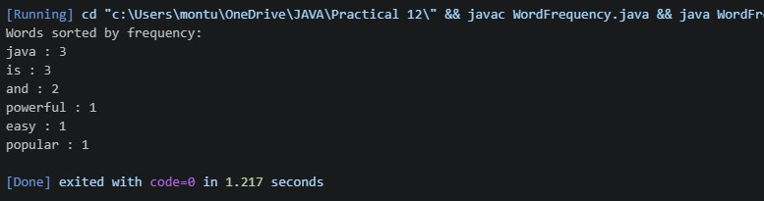
PR 02: | 2. Unique visitors: from a list of login names with repeats, use a HashSet to count unique users and a LinkedHashSet to keep first-seen order; print the  unique count and the first three disƟnct names.
CODE : | import java.util.*;  public class UniqueVisitors {  public static void main(String[] args) {

List<String> logins = Arrays.asList(
"Manthan", "Bhavy", "Om", "Manthan","Om", "Bhavy", "Neha", "Amit" );
// HashSet for unique count HashSet<String> uniqueUsers = new
HashSet<>(logins);
// LinkedHashSet for first-seen order LinkedHashSet<String> orderedUsers = new
LinkedHashSet<>(logins);
System.out.println("Unique users: " + uniqueUsers.size());
System.out.println("First three distinct users:"); int count = 0;
for (String user : orderedUsers) { System.out.println(user); count++;
if (count == 3) break;
}
}
}
OUTPU T : | 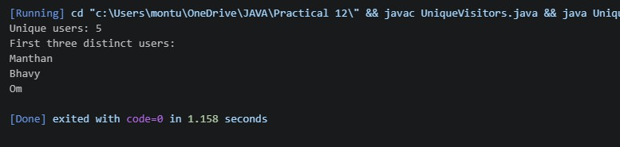

Practical-13

PR 01: | 1. Generic containers: a generic Box with get/set and a Pair; use them with different types to show type safety without casts, and write a generic method  that returns the first element of any array.
CODE : | public class BoundedStats {  public static <N extends Number> double average(N[] values) {  double sum = 0;  for (N value : values) {  sum += value.doubleValue();  }  return sum / values.length;  }  public static void main(String[] args) { Integer[] integers = {10, 20, 30, 40};  Double[] doubles = {10.5, 20.5, 30.5};  Long[] longs = {100L, 200L, 300L};  System.out.println("Integer average: " + average(integers));  System.out.println("Double average: " + average(doubles));  System.out.println("Long average: " + average(longs));  }  }
OUTPU T: | 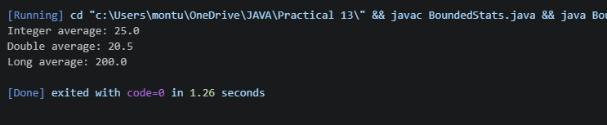
PR 02: | 3. (For Advanced Learners – home) Implement a small generic container of your choice (e.g. a stack) backed by an array, reuse it for two different types,  and handle the empty case sensibly.
CODE : | class MyStack<T> {  private T[] stack; private int top;

@SuppressWarnings("unchecked") public MyStack(int size) {
stack = (T[]) new Object[size]; top = -1;
}
public void push(T value) {

if (top == stack.length - 1) { System.out.println("Stack is full!"); return;
}

stack[++top] = value;
}
public T pop() { if (top == -1) {
System.out.println("Stack is empty!"); return null;
}
return stack[top--];
}
public T peek() { if (top == -1) {
System.out.println("Stack is empty!"); return null;
}

return stack[top];
}
public boolean isEmpty() { return top == -1;
}
}
public class GenericStackDemo {

public static void main(String[] args) {
// Integer stack
MyStack<Integer> intStack = new MyStack<>(5);
intStack.push(10); intStack.push(20); intStack.push(30);
System.out.println("Integer stack pop: "
+ intStack.pop());
System.out.println("Integer stack peek: "
+ intStack.peek());
// String stack
MyStack<String> stringStack = new MyStack<>(5);
stringStack.push("Java"); stringStack.push("Python"); stringStack.push("C++");
System.out.println("String stack pop: "
+ stringStack.pop());
System.out.println("String stack peek: "
+ stringStack.peek());
// Empty case
while (!stringStack.isEmpty()) { stringStack.pop();
}

System.out.println("Trying to pop from empty stack:"); stringStack.pop();
}
}

OUTPU T : | 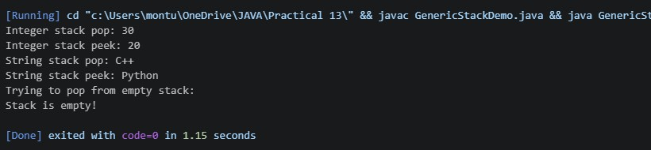

Practical-14
PR 01: | 1. Assemble and test: build a Ɵny layered app (a model, a service using an ArrayList, and a menu main), then write two or three JUnit @Test methods checking that adding increases the count and an invalid acƟon throws —  pracƟce before tesƟng MiniBank.
CODE : | public class Account { private String name; private double balance;  public Account(String name, double balance) { this.name = name;  this.balance = balance;  }  public String getName() { return name;  }  public double getBalance() { return balance;  }  }  import java.util.ArrayList; public class AccountService {  private ArrayList<Account> accounts = new ArrayList<>();  public void addAccount(Account account) { if (account == null) {  throw new IllegalArgumentException("Account cannot be null");

}
accounts.add(account);
}
public int getCount() { return accounts.size();
}

public Account getAccount(int index) {
if (index < 0 || index >= accounts.size()) {
throw new IllegalArgumentException("Invalid account index");
}
return accounts.get(index);
}
}
import java.util.Scanner; public class Main {
public static void main(String[] args) {
Scanner sc = new Scanner(System.in); AccountService service = new AccountService();
int choice; do {
System.out.println("\n1. Add Account");
System.out.println("2. View Account Count"); System.out.println("3. Exit");
System.out.print("Enter choice: "); choice = sc.nextInt(); sc.nextLine();
switch (choice) { case 1:
System.out.print("Enter name: "); String name = sc.nextLine();

System.out.print("Enter balance: "); double balance = sc.nextDouble();
service.addAccount(new Account(name,
balance));

System.out.println("Account added!"); break;
case 2:
System.out.println("Total accounts: " + service.getCount());
break;
case 3:
System.out.println("Exiting..."); break;
default:
System.out.println("Invalid choice!");
}
} while (choice != 3); sc.close();
}
}
public class AccountServiceTest { public static void main(String[] args) {
addingAccountIncreasesCount(); addingTwoAccountsIncreasesCountByTwo(); invalidAccountThrowsException();
System.out.println("\nAll tests passed!");
}

static void addingAccountIncreasesCount() { AccountService service = new AccountService();
service.addAccount(new Account("Om", 1000));

if (service.getCount() != 1) {
throw new AssertionError("Count should be 1");
}
System.out.println("Test 1 passed");
}

static void addingTwoAccountsIncreasesCountByTwo() { AccountService service = new AccountService();
service.addAccount(new Account("Om", 1000));
service.addAccount(new Account("Rahul", 2000));
if (service.getCount() != 2) {
throw new AssertionError("Count should be 2");
}
System.out.println("Test 2 passed");
}
static void invalidAccountThrowsException() { AccountService service = new AccountService();
try {
service.addAccount(null);
throw new AssertionError("Exception was not thrown");
} catch (IllegalArgumentException expected) { System.out.println("Test 3 passed");
}
}
}
OUTPU T: | 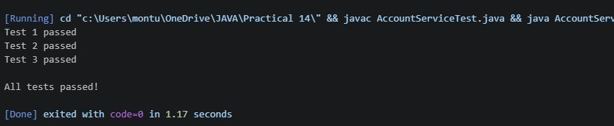
PR 02: | 2. (For Advanced Learners – home) Organise that app into packages, build a runnable JAR, and add a test that saves and reloads its data unchanged.
CODE :

package model;
import java.io.Serializable;

public class BankAccount implements Serializable {
private static final long serialVersionUID = 1L; private String name;
private double balance;
public BankAccount(String name, double balance) { this.name = name;
this.balance = balance;
}
public String getName() { return name;
}

public double getBalance() { return balance;
}
}
package service;
import model.BankAccount; import java.util.ArrayList; import java.io.*;
public class BankService {

private ArrayList<BankAccount> accounts = new ArrayList<>();
public void addAccount(BankAccount account) { if (account == null) {
throw new IllegalArgumentException("Account cannot be null");
}
accounts.add(account);

}
public int getCount() { return accounts.size();
}

public BankAccount getAccount(int index) { if (index < 0 || index >= accounts.size()) {
throw new IllegalArgumentException("Invalid account index");
}
return accounts.get(index);
}
public void saveData(String filename) throws IOException
{
try (ObjectOutputStream out = new ObjectOutputStream(
new FileOutputStream(filename))) {
out.writeObject(accounts);
}
}
@SuppressWarnings("unchecked") public void loadData(String filename)
throws IOException, ClassNotFoundException {

try (ObjectInputStream in = new ObjectInputStream( new FileInputStream(filename))) {

accounts = (ArrayList<BankAccount>) in.readObject();
}
}
}
package app;
import model.BankAccount; import service.BankService; import java.util.Scanner;

public class BankMain {
public static void main(String[] args) {

Scanner sc = new Scanner(System.in); BankService service = new BankService();
int choice; do {
System.out.println("\n1. Add Account");
System.out.println("2. View Account Count"); System.out.println("3. Save Data"); System.out.println("4. Load Data"); System.out.println("5. Exit");
System.out.print("Enter choice: "); choice = sc.nextInt(); sc.nextLine();
try {
switch (choice) {

case 1:
System.out.print("Enter name: "); String name = sc.nextLine();
System.out.print("Enter balance: "); double balance = sc.nextDouble();

service.addAccount(new BankAccount(name,
balance));

System.out.println("Account added!"); break;
case 2:
System.out.println(
"Total accounts: " + service.getCount()
);
break;

case 3:
service.saveData("accounts.dat"); System.out.println("Data saved!"); break;
case 4:
service.loadData("accounts.dat"); System.out.println("Data loaded!"); break;
case 5:
System.out.println("Exiting..."); break;
default:
System.out.println("Invalid choice!");
}
} catch (Exception e) {
System.out.println("Error: " + e.getMessage());
}
} while (choice != 5); sc.close();
}
}
import model.BankAccount; import service.BankService;
public class BankDataTest {
public static void main(String[] args) throws Exception { BankService original = new BankService(); original.addAccount(new BankAccount("Om", 5000));
original.addAccount(new BankAccount("Rahul", 3000));
original.saveData("test-accounts.dat"); BankService restored = new BankService();

restored.loadData("test-accounts.dat");
if (original.getCount() != restored.getCount()) {
throw new AssertionError("Account count does not match");
}

for (int i = 0; i < original.getCount(); i++) {
BankAccount a = original.getAccount(i); BankAccount b = restored.getAccount(i);

if (!a.getName().equals(b.getName())
|| a.getBalance() != b.getBalance()) {
throw new AssertionError("Account data does not
match");
}
}
System.out.println("Save and reload test passed!"); System.out.println("Account data is unchanged.");
}
}
OUTPU T : | 

